Here’s a Halloween word ladder. Enjoy! Start with the word “trick”:

Trick Change 1 letter to make a sport in which contestants run around a large oval.
Track Change 1 letter to make a very small amount of a substance, or to make a copy of a drawing by putting a transparent sheet of paper over the drawing and copying it.
Trace Change 1 letter to make a word that means to prepare for something unexpected; a part that adds physical strength or support or a device that supports a part of the body or teeth.
Brace Change 1 letter to make a prayer often said before a meal; a charming or attractive trait or characteristic.
Grace Change 1 letter to make a word that describes when you chop of cheese to sprinkle on a pizza; to grind noisily, as when you grind your teeth.
Grate Rearrange the letters to make another word for terrific or wonderful.
Great Change 1 letter to make a word that goes with the first word in the ladder and is often used at Halloween!
Treat!

Trick or Treat! Happy Halloween!
Tim Rasinski 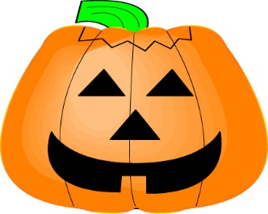
For more see: Rasinski, T.: Daily Word Ladders, K-1, 1-2, 2-4. 4-6
Vocabulary Ladders, 1, 2, 3, 4, 5, 6

